| Investigation of the relationship between the diameter and the terminal velocity of an object    **IB Candidate Code: lsh546**  **Word Count: 2989** |
| --- |

**1 Introduction 2**

1.1 Research Question 2

1.2 Background Theory 2

1.3 Hypothesis 5

1.4 Variables 5

1.5 Important values 7

**2 Experiment 9**

2.1 Apparatus 9

2.2 Procedure 9

2.3 Diagram 13

2.4 Risk Assessment 14

**3 Analysis 14**

3.1 Raw Data 16

3.2 Processed Data 16

3.3 Graphical Analysis 18

3.4 Conclusion 20

**4 Evaluation 21**

4.2 Limitation 21

4.3 Extensions and Modifications 22

**References 23**

## 

## 1 Introduction

This investigation aims to model and determine the relationship between the radius of a sphere and its terminal velocity when dropped from a constant height in a container containing a viscous fluid, 99.5% glycerin. In this experiment, various sizes of steel spheres were tested in the same container, and the results were analyzed using the video analysis software, “Tracker”. They showed that the terminal velocity of the spheres is directly proportional to their radius. Understanding how the size of an object affects its terminal velocity is important in applications involving designing parachutes and other equipment to control the speed of descent (votatera, 2024). These principles are widely used in fields such as engineering, where predicting the motion of particles in fluids is essential (Javatpoint, 2024). Additionally, this investigation ties into key physics concepts, such as Newton’s laws, drag forces, and fluid dynamics. I recently visited the Euro Space Center in Belgium and was specifically interested in the part where they explained the atmospheric re-entry of spacecraft. While spacecraft do not reach an actual terminal velocity due to decreasing altitude and varying atmospheric density, the concept of drag force balancing with gravitational force is comparable in certain aspects. I was eager to take the opportunity of the physics IA to explore the physics behind this in a school investigation.

### 1.1 Research Question

How does the diameter of a sphere affect its vertical terminal velocity in 99.5% glycerin when dropped without initial speed?

### 1.2 Background Theory

| **Symbol** | **Meaning** | **Unit** |
| --- | --- | --- |
|  | Gravitational Force or Weight |  |
|  | Drag Force |  |
|  | Buoyant Force |  |
|  | Sphere Velocity |  |
|  | Terminal Velocity |  |
|  | Sphere Mass |  |
|  | Gravitational Acceleration |  |
|  | Sphere Radius |  |
|  | Fluid Density |  |
|  | Sphere Density |  |
|  | Displaced Fluid Volume |  |
|  | Fluid Dynamic Viscosity |  |

Table 1: Symbols

Newton's second law describes that terminal velocity is the constant speed a falling object reaches when the forces acting upwards, including drag force ([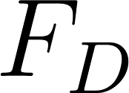](https://www.codecogs.com/eqnedit.php?latex=F_D#0)) and buoyant force ([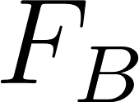](https://www.codecogs.com/eqnedit.php?latex=F_B#0)), are equal to the object’s weight. At this point, the upward and downward forces are of equal magnitude, and the object continues to move at a uniform speed. This equilibrium can be analyzed using the relation [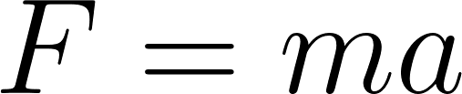](https://www.codecogs.com/eqnedit.php?latex=F%3Dma#0), where the net force is zero and the acceleration is null (Benson, 2024).

The symbols of all formulas are explained in Table 1 on pages 2 and 3.

The gravitational force acting on an object is:

[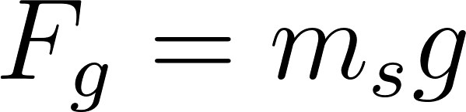](https://www.codecogs.com/eqnedit.php?latex=F_g%3Dm_sg#0)

For a sphere, the mass can be expressed in terms of its density ([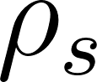](https://www.codecogs.com/eqnedit.php?latex=%5Crho%20_s#0)) and volume ([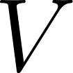](https://www.codecogs.com/eqnedit.php?latex=V#0)) (Deziel, 2020).

[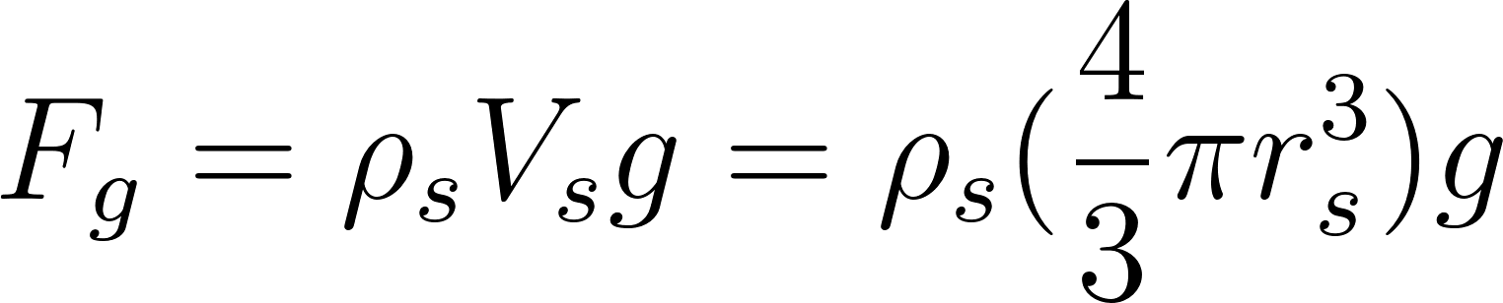](https://www.codecogs.com/eqnedit.php?latex=F_g%3D%5Crho%20_s%20V_sg%3D%5Crho%20_s(%5Cfrac%7B4%7D%7B3%7D%5Cpi%20r_s%5E3)g#0)

The buoyant force on an object is the weight of the displaced fluid by the object, as described by Archimede’s principle (Khan Academy, 2023).

Figure 1: Forces diagram

[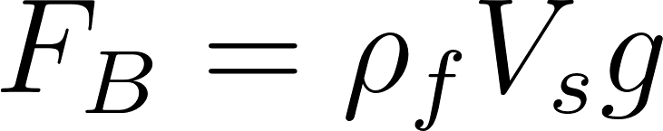](https://www.codecogs.com/eqnedit.php?latex=F_B%3D%5Crho%20_f%20V_sg#0)

For a sphere, substituting the volume formula, we get

[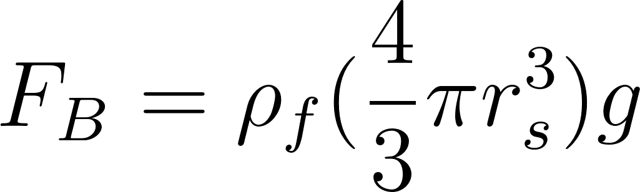](https://www.codecogs.com/eqnedit.php?latex=F_B%3D%5Crho%20_f%20(%5Cfrac%7B4%7D%7B3%7D%5Cpi%20r_s%5E3)g#0)

This force acts upwards, opposite to the downward gravitational force.  
  
For small objects moving at slow velocities, such as the spheres used in the experiment moving in a viscous liquid such as glycerine 99.5%, the drag force ([](https://www.codecogs.com/eqnedit.php?latex=F_D#0)) is provided by Stokes’ Law (Lumen Learning, 2022).

[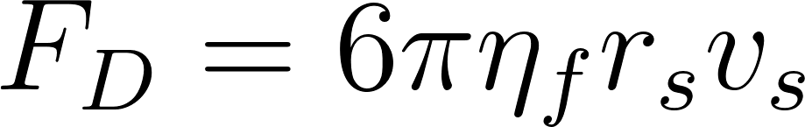](https://www.codecogs.com/eqnedit.php?latex=F_D%3D6%5Cpi%20%5Ceta%20_fr_sv_s#0)

Stokes’ Law is valid under laminar flow conditions (low Reynolds number), where the fluid’s motion is smooth and predictable (COMSOL Documentation, 2021).

[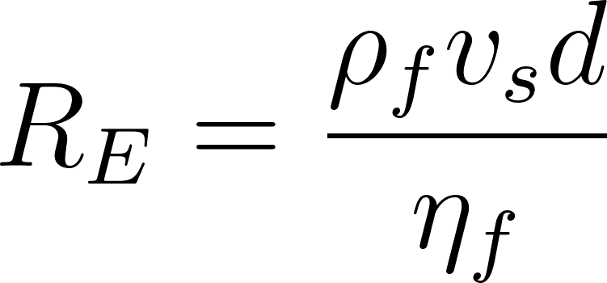](https://www.codecogs.com/eqnedit.php?latex=R_E%3D%5Cfrac%7B%5Crho_f%20v_sd%7D%7B%5Ceta%20_f%7D#0)

Where: [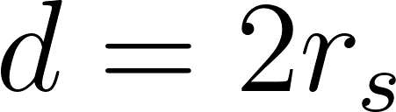](https://www.codecogs.com/eqnedit.php?latex=d%3D2r_s#0)

For [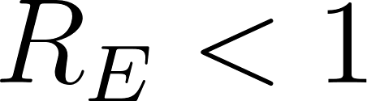](https://www.codecogs.com/eqnedit.php?latex=R_E%20%3C1#0), the flow is laminar, ensuring that assumptions of Stokes’ Law hold true. If [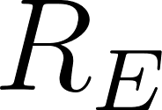](https://www.codecogs.com/eqnedit.php?latex=R_E#0) becomes large, the flow transitions to turbulent, adding complexity (Rehm & Schubert, 2008).

My assumptions are:

* The steel sphere is spherical.
* The flow around the sphere is steady and laminar (low Reynolds number). I will check later with the calculated velocities to see if the Reynolds number is indeed very small.
* Stokes' law applies to drag force.
* Glycerin properties (density, viscosity) are standard at room temperature.

As discussed above, for [](https://www.codecogs.com/eqnedit.php?latex=v#0) to be [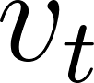](https://www.codecogs.com/eqnedit.php?latex=v_t#0), the equation may be expressed as follows:

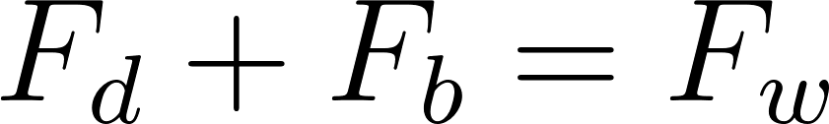

Thus, the formula can be derived as follows using the equations described above:

[](https://www.codecogs.com/eqnedit.php?latex=%20m_sg%3D6%5Cpi%20%5Ceta_fr_sv_s%2B%5Crho%20_f%20V_sg%20#0)

After rearranging for the terminal velocity

[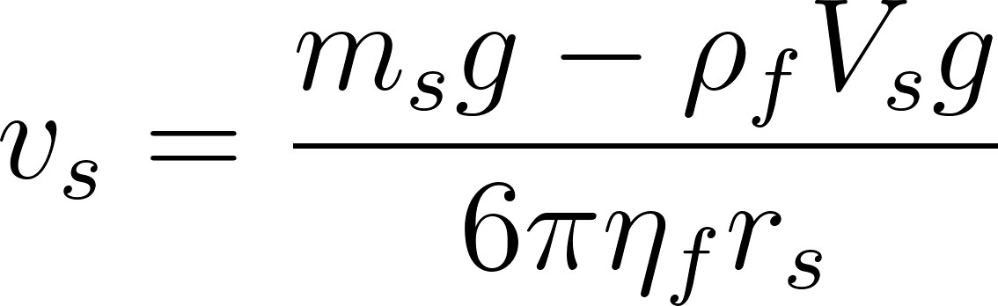](https://www.codecogs.com/eqnedit.php?latex=%20v_s%20%3D%20%5Cfrac%7Bm_%7Bs%7Dg%20-%20%5Crho_f%20V_%7Bs%7Dg%7D%7B6%20%5Cpi%20%5Ceta_f%20r_s%7D%20#0)

Inserting the formulae of the mass and the volume

[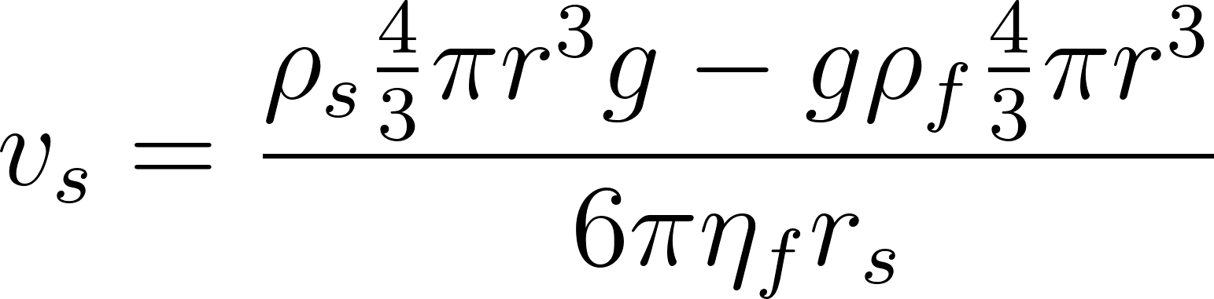](https://www.codecogs.com/eqnedit.php?latex=v_s%20%3D%20%5Cfrac%7B%5Crho%20_s%5Cfrac%7B4%7D%7B3%7D%5Cpi%20r%5E3%20g%20-%20g%5Crho_f%20%5Cfrac%7B4%7D%7B3%7D%5Cpi%20r%5E3%7D%7B6%20%5Cpi%20%5Ceta_f%20r_s%7D#0)

Hence, the terminal velocity is expressed as:

[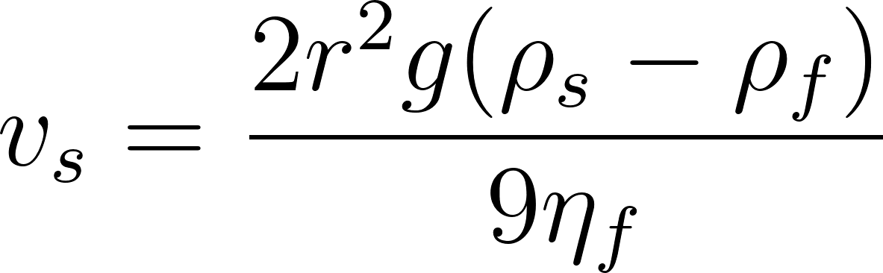](https://www.codecogs.com/eqnedit.php?latex=%20v_s%20%3D%20%5Cfrac%7B2%20r%5E2%20g%20(%5Crho_s%20-%20%5Crho_f)%7D%7B9%20%5Ceta_f%7D%20%20#0)

### 1.3 Hypothesis

The equation shows that as the diameter of a sphere increases, its terminal velocity in 99.5% glycerin will increase proportionally to the square of its radius. This is because terminal velocity is directly proportional to the square of the sphere’s radius, given a constant fluid viscosity, the density difference between the sphere and fluid, and gravitational acceleration.

[](https://www.codecogs.com/eqnedit.php?latex=%20v_s%20%3D%20%5Cfrac%7B2%20r%5E2%20g%20(%5Crho_s%20-%20%5Crho_f)%7D%7B9%20%5Ceta_f%7D%20%20#0)

### 1.4 Variables

| Controlled Variables | Density of the fluid | A high fluid density is essential for the experiment to rapidly attain the sphere terminal velocity (Aaron, 2022). Thus, 99.5% glycerin is used as it is easy to find, dense, and has well-known properties. However, removing as many air bubbles as possible is necessary to maintain consistent fluid dynamics (Fluigent, 2023) by pouring it slowly on the walls of the container while having it slanted to keep smooth pouring. |
| --- | --- | --- |
|  | Method of release | The sphere needs to touch the fluid before release to avoid initial velocity. Straight release is needed because spin can affect drag force as a viscous torque opposite to the direction of the spin would impact the terminal velocity of the sphere (Grugel, 1998). Furthermore, wobble increases the cross-sectional area of the ball, which increases the drag force (Kagan, 2018). |
|  | Temperature of the fluid | It is essential to keep the glycerin at room temp (± 20°C) as its viscosity and density can change with temperature and change its fluid dynamics. (Springer Verlag, 2013) |
|  | Dimensions of the container | I will keep the exact dimensions of the graduated cylinder so as not to add or remove wall-induced fluid resistance or turbulence so all the trials are in the same environment. |
|  | Calibration of measurement tools | Calibrating and maintaining consistent settings for measurement tools, such as the camera angle, frame resolution, and frame rate, helps to ensure accurate and reliable measurement of the spheres' terminal velocities. |
|  | Density of the sphere | The sphere density directly impacts its mass, thus, its downward gravitational force. It is controlled by using spheres from the same set. |
| Independent Variable | Radius of the sphere | Changing the sphere radius allows observation of its impact on terminal velocity. |
| Dependent Variable | Terminal velocity of the sphere | The time taken by the spheres to travel a distance through 99.5% glycerin is measured using video analysis with the “Tracker” app. |

### 1.5 Important values

These values will be used later when calculating the theoretical terminal velocity of the spheres, page 15.

Density of the sphere ([](https://www.codecogs.com/eqnedit.php?latex=%5Crho%20_s#0)):

* [](https://www.codecogs.com/eqnedit.php?latex=d%3D8.00%20%5Cpm%200.05%20mm#0)
* [](https://www.codecogs.com/eqnedit.php?latex=r%3D4.00mm%5CRightarrow%200.400%20cm#0)
* [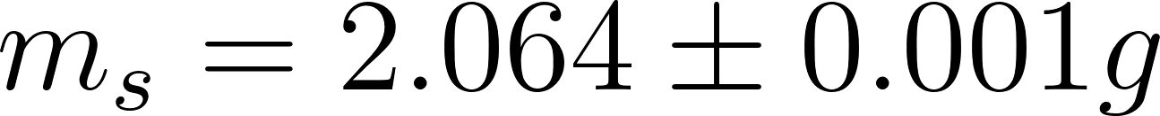](https://www.codecogs.com/eqnedit.php?latex=m_s%3D2.064%20%5Cpm%200.001%20g#0)

Volume of the sphere:

[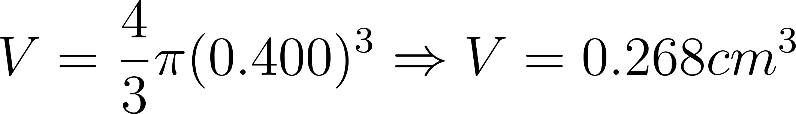](https://www.codecogs.com/eqnedit.php?latex=V%3D%5Cfrac%7B4%7D%7B3%7D%5Cpi%20(0.400)%5E3%5CRightarrow%20V%3D0.268%20cm%5E3#0)

To calculate the density:

[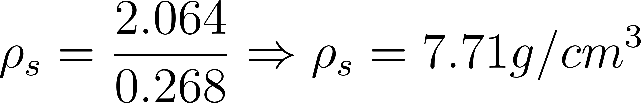](https://www.codecogs.com/eqnedit.php?latex=%5Crho%20_s%3D%5Cfrac%7B2.064%7D%7B0.268%7D%5CRightarrow%20%5Crho%20_s%3D7.71%20g%2Fcm%5E3#0)

To calculate the uncertainty of the density of the spheres:

[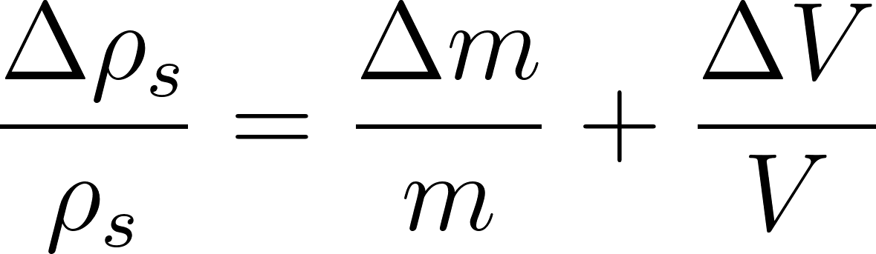](https://www.codecogs.com/eqnedit.php?latex=%5Cfrac%7B%5CDelta%20%5Crho%20_s%7D%7B%5Crho%20_s%7D%3D%5Cfrac%7B%5CDelta%20m%7D%7Bm%7D%2B%5Cfrac%7B%5CDelta%20V%7D%7BV%7D#0)

Uncertainty in mass:

[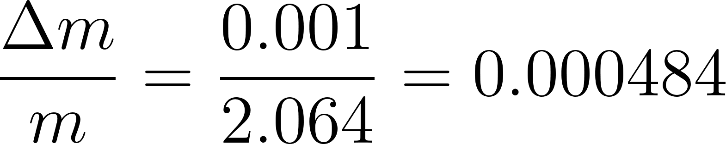](https://www.codecogs.com/eqnedit.php?latex=%5Cfrac%7B%5CDelta%20m%7D%7Bm%7D%3D%5Cfrac%7B0.001%7D%7B2.064%7D%3D0.000484#0)

Volume depends on [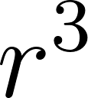](https://www.codecogs.com/eqnedit.php?latex=r%5E3#0), so the fractional uncertainty in volume is:

[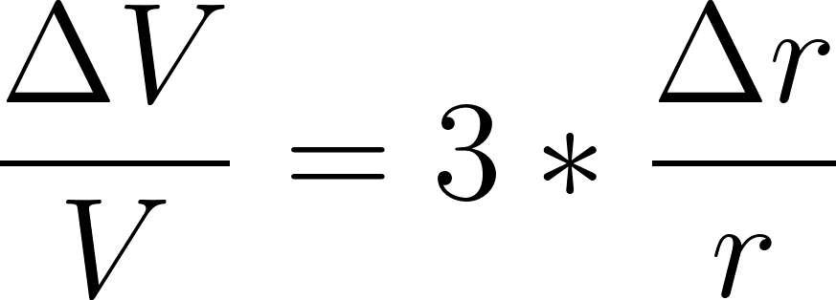](https://www.codecogs.com/eqnedit.php?latex=%5Cfrac%7B%5CDelta%20V%7D%7BV%7D%3D3*%5Cfrac%7B%5CDelta%20r%7D%7Br%7D#0)

[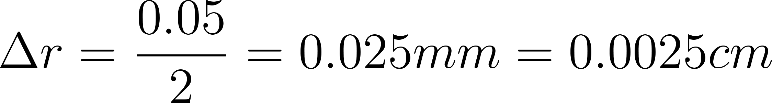](https://www.codecogs.com/eqnedit.php?latex=%5CDelta%20r%3D%5Cfrac%7B0.05%7D%7B2%7D%3D0.025mm%3D0.0025cm#0)

[](https://www.codecogs.com/eqnedit.php?latex=%5Cfrac%7B%5CDelta%20r%7D%7Br%7D%3D%5Cfrac%7B0.0025%7D%7B0.400%7D%3D0.00625%5CRightarrow%20%5Cfrac%7B%5CDelta%20V%7D%7BV%7D%3D3*0.00625%3D0.01875#0)

The uncertainty in density:

[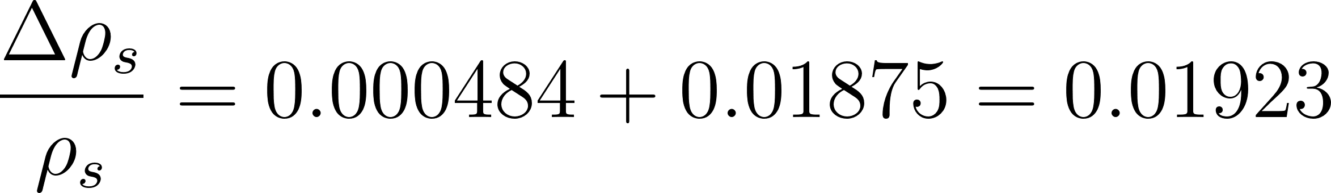](https://www.codecogs.com/eqnedit.php?latex=%5Cfrac%7B%5CDelta%20%5Crho%20_s%7D%7B%5Crho%20_s%7D%3D0.000484%2B0.01875%3D0.01923#0)

[](https://www.codecogs.com/eqnedit.php?latex=%5CDelta%20%5Crho%20_s%3D0.01923*7.71%3D0.15%20g%2Fcm%5E3#0)

Finally:

[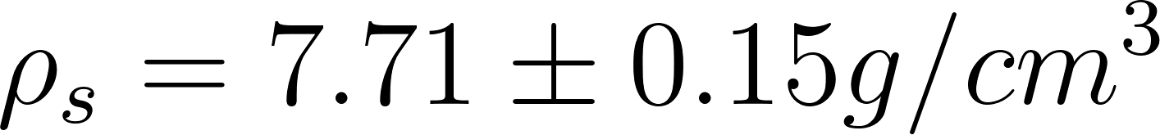](https://www.codecogs.com/eqnedit.php?latex=%5Crho%20_s%3D7.71%5Cpm%200.15%20g%2Fcm%5E3#0)

This aligns very closely with the value of 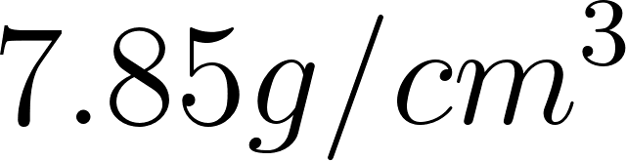value I found online (Amardeep Steel Centre, 2024).

Density of glycerin ([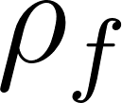](https://www.codecogs.com/eqnedit.php?latex=%5Crho%20_f#0)):

* [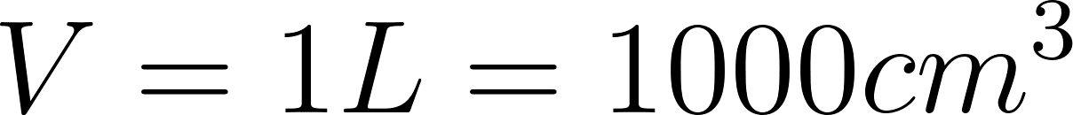](https://www.codecogs.com/eqnedit.php?latex=V%3D1L%3D1000cm%5E3#0)

To calculate the density, given mass:

[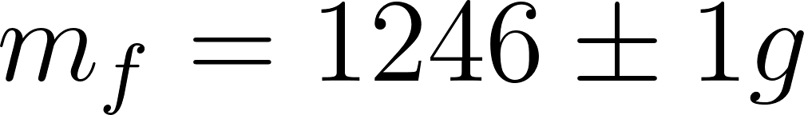](https://www.codecogs.com/eqnedit.php?latex=m%20_f%3D1246%20%5Cpm%201g#0)

[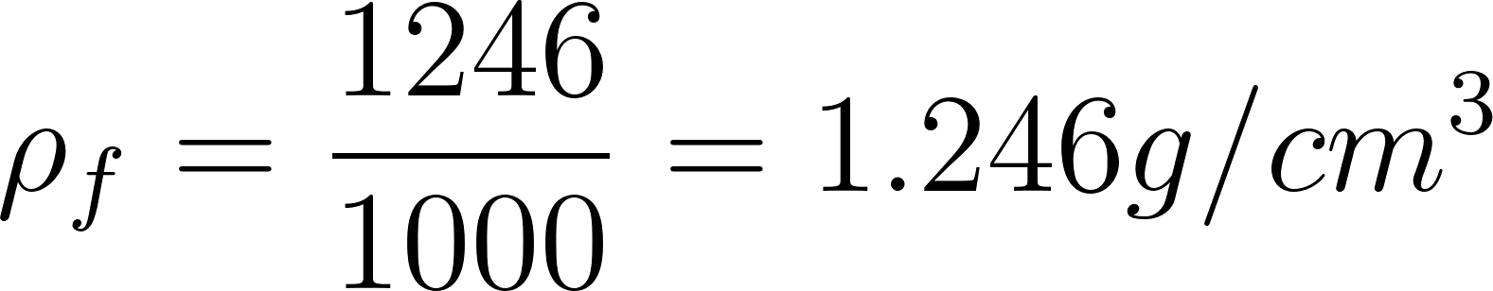](https://www.codecogs.com/eqnedit.php?latex=%5Crho%20_f%3D%5Cfrac%7B1246%7D%7B1000%7D%3D1.246g%2Fcm%5E3#0)

To calculate the uncertainty of the density of the spheres, we use the formula for the propagation of uncertainties in the formula booklet:

[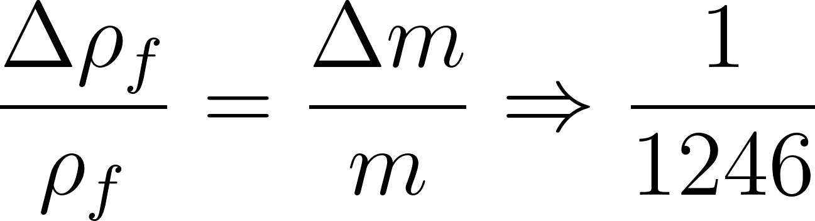](https://www.codecogs.com/eqnedit.php?latex=%5Cfrac%7B%5CDelta%20%5Crho%20_f%7D%7B%5Crho%20_f%7D%3D%5Cfrac%7B%5CDelta%20m%7D%7Bm%7D%5CRightarrow%20%5Cfrac%7B1%7D%7B1246%7D#0)

Since volume has no uncertainty, assuming exactly 1 L:

[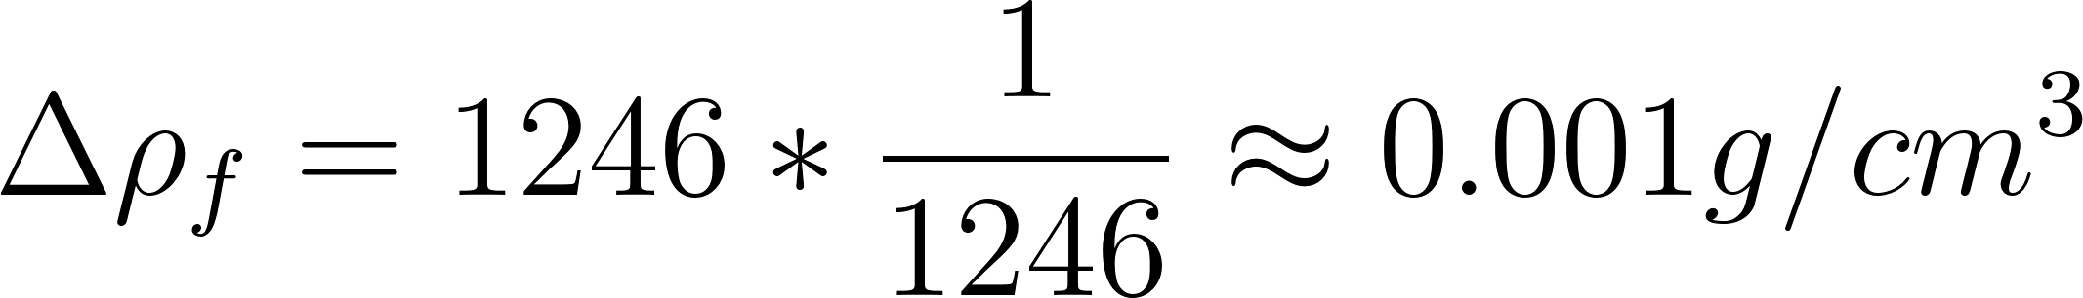](https://www.codecogs.com/eqnedit.php?latex=%5CDelta%20%5Crho%20_f%3D1246*%5Cfrac%7B1%7D%7B1246%7D%5Capprox%200.001%20g%2Fcm%5E3#0)

Finally:

[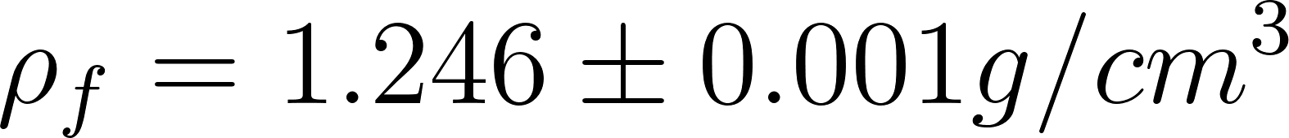](https://www.codecogs.com/eqnedit.php?latex=%5Crho%20_f%3D1.246%5Cpm%200.001%20g%2Fcm%5E3#0)

This aligns very closely with the [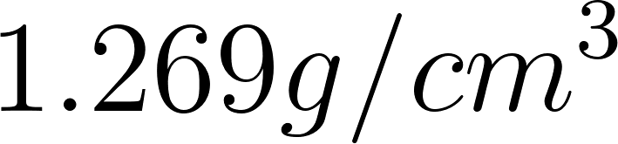](https://www.codecogs.com/eqnedit.php?latex=1.269g%2Fcm%5E3#0) value at 20°C I found online (Springer Verlag, 2013). The slight change could be due to air bubbles or human error. Furthermore, the volume weighted may not have been perfectly 1L or 1000 cm³.

## 2 Experiment

### 2.1 Apparatus

* 18 spheres of different diameters
  + 3 spheres of ± 8.00 mm
  + 3 spheres of ± 7.00 mm
  + 3 spheres of ± 6.00 mm
  + 3 spheres of ± 6.50 mm
  + 3 spheres of ± 4.50 mm
  + 3 spheres of ± 3.50 mm.
* 1 digital caliper ± 0.02 mm
* 1 bottle of 99.5% glycerin
* 1 phone filming at 60 fps
* 1 graduated cylinder
* 1 digital weighing scale ± 0.1 g
* 1 tweezers
* Tracker App. It is a free video analysis and modeling tool built on the Open Source Physics (OSP) Java framework.

### 2.2 Procedure

The terminal velocity is calculated by dividing a distance by time, which can be applied when and if the velocity is constant. The next calculation is to show that the terminal velocity will almost be immediately attained, validating its calculation by doing distance over time. Using Newton’s second law and solving the differential equation for velocity, we can determine the time it takes to approach 99% of its terminal velocity.

The equation of motion:

[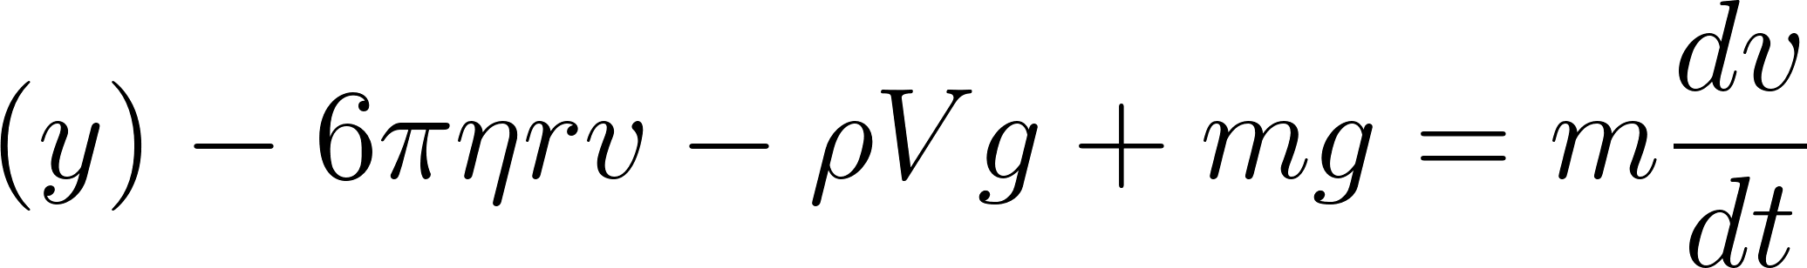](https://www.codecogs.com/eqnedit.php?latex=%20(y)%20-%206%5Cpi%20%5Ceta%20r%20v%20-%20%5Crho%20V%20g%20%2B%20m%20g%20%3D%20m%20%5Cfrac%7Bdv%7D%7Bdt%7D%20#0)

Rewriting it:

[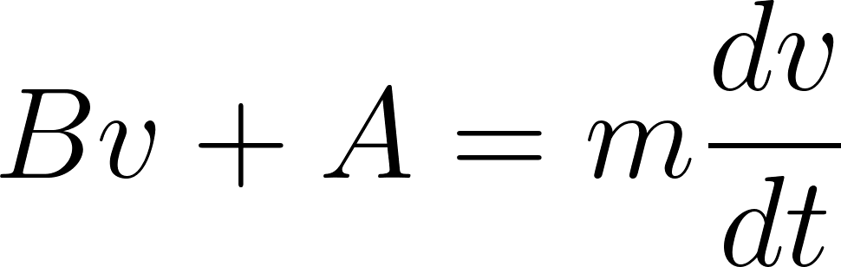](https://www.codecogs.com/eqnedit.php?latex=Bv%20%2B%20A%20%3D%20m%20%5Cfrac%7Bdv%7D%7Bdt%7D#0)

Where:

* [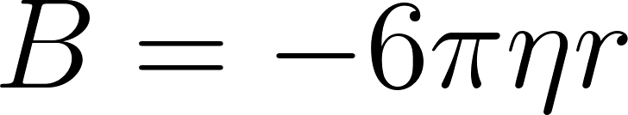](https://www.codecogs.com/eqnedit.php?latex=B%3D-6%5Cpi%20%5Ceta%20r#0)
* [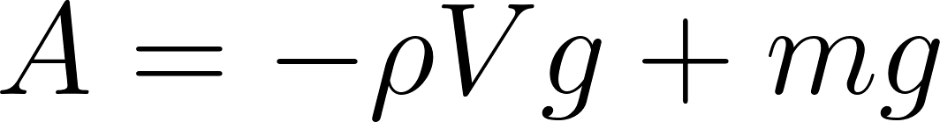](https://www.codecogs.com/eqnedit.php?latex=A%3D-%5Crho%20Vg%2Bmg#0)

Rearranging and integrating:

[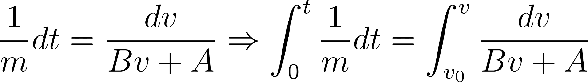](https://www.codecogs.com/eqnedit.php?latex=%5Cfrac%7B1%7D%7Bm%7D%20dt%20%3D%20%5Cfrac%7Bdv%7D%7BBv%20%2B%20A%7D%20%5CRightarrow%20%5Cint_0%5Et%20%5Cfrac%7B1%7D%7Bm%7D%20dt%20%3D%20%5Cint_%7Bv_0%7D%5Ev%20%5Cfrac%7Bdv%7D%7BBv%20%2B%20A%7D#0)

Let:



Substitute:

[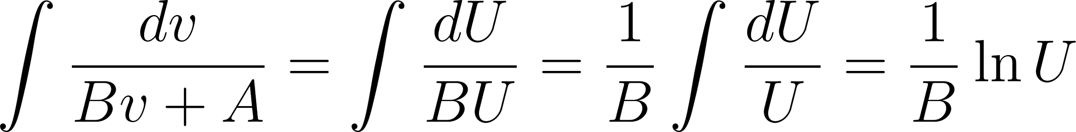](https://www.codecogs.com/eqnedit.php?latex=%5Cint%20%5Cfrac%7Bdv%7D%7BBv%20%2B%20A%7D%20%3D%20%5Cint%20%5Cfrac%7BdU%7D%7BBU%7D%20%3D%20%5Cfrac%7B1%7D%7BB%7D%20%5Cint%20%5Cfrac%7BdU%7D%7BU%7D%20%3D%20%5Cfrac%7B1%7D%7BB%7D%20%5Cln%20U%20%20#0)

Returning to the original variables:

[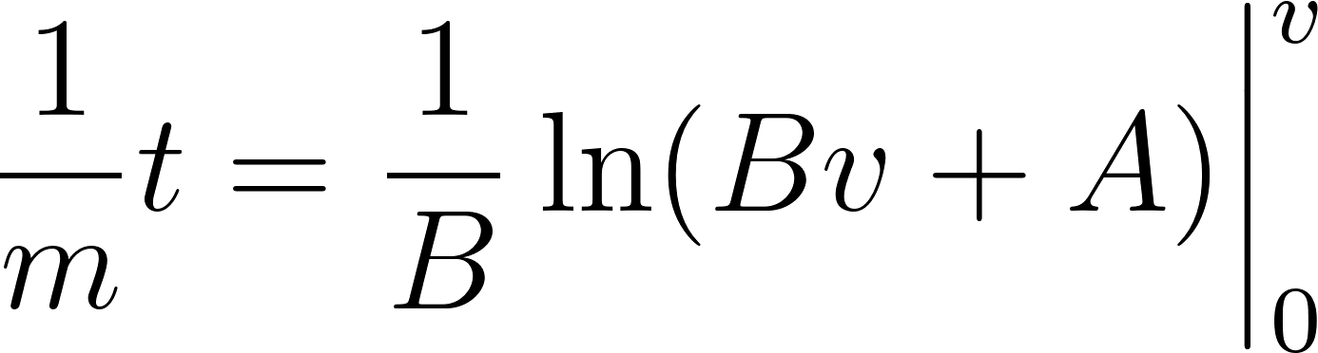](https://www.codecogs.com/eqnedit.php?latex=%5Cfrac%7B1%7D%7Bm%7D%20t%20%3D%20%5Cfrac%7B1%7D%7BB%7D%20%5Cln(Bv%20%2B%20A)%20%5Cbigg%7C_0%5Ev%20%20#0)

[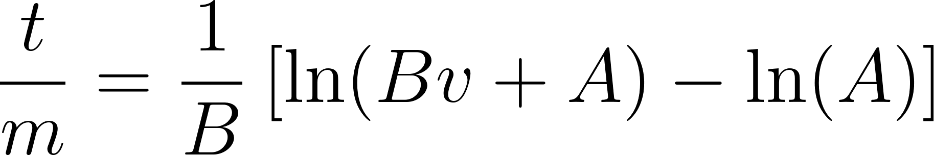](https://www.codecogs.com/eqnedit.php?latex=%5Cfrac%7Bt%7D%7Bm%7D%20%3D%20%5Cfrac%7B1%7D%7BB%7D%20%5Cleft%5B%5Cln(Bv%20%2B%20A)%20-%20%5Cln(A)%5Cright%5D%20%20#0)

Simplify:

[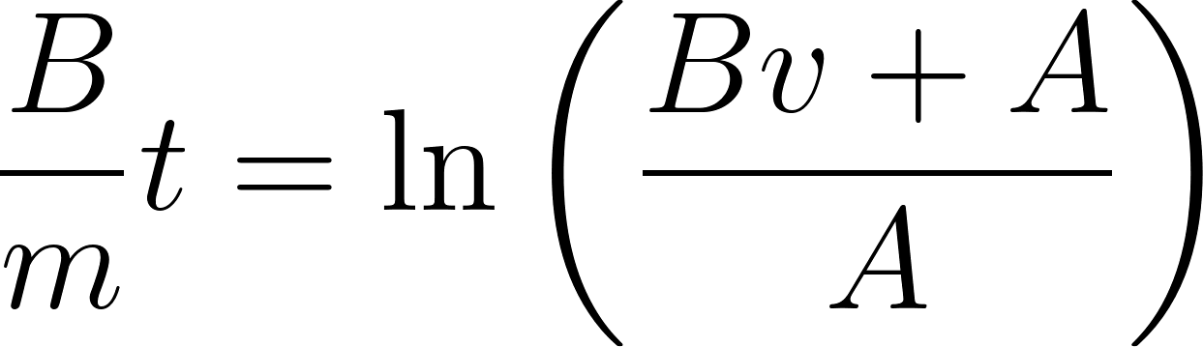](https://www.codecogs.com/eqnedit.php?latex=%5Cfrac%7BB%7D%7Bm%7D%20t%20%3D%20%5Cln%5Cleft(%5Cfrac%7BBv%20%2B%20A%7D%7BA%7D%5Cright)%20%20#0)

Removing ln:

[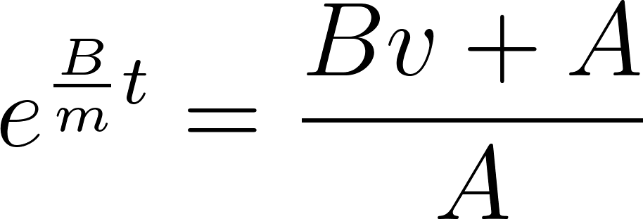](https://www.codecogs.com/eqnedit.php?latex=e%5E%7B%5Cfrac%7BB%7D%7Bm%7Dt%7D%20%3D%20%5Cfrac%7BBv%20%2B%20A%7D%7BA%7D%20%20#0)

Solving for [](https://www.codecogs.com/eqnedit.php?latex=v#0):

[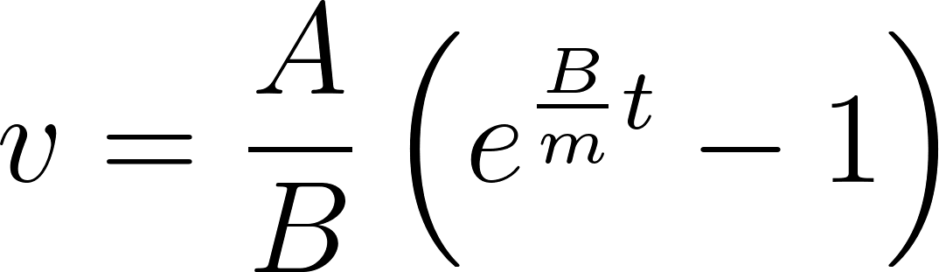](https://www.codecogs.com/eqnedit.php?latex=v%20%3D%20%5Cfrac%7BA%7D%7BB%7D%20%5Cleft(e%5E%7B%5Cfrac%7BB%7D%7Bm%7Dt%7D%20-%201%5Cright)#0)

Terminal velocity

[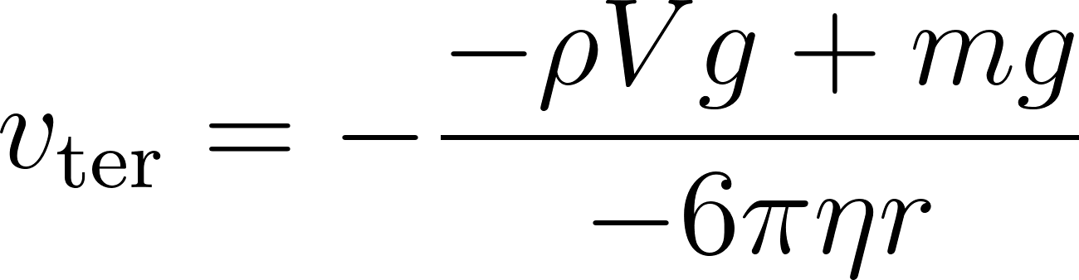](https://www.codecogs.com/eqnedit.php?latex=v_%7B%5Ctext%7Bter%7D%7D%20%3D%20-%5Cfrac%7B-%5Crho%20Vg%2Bmg%7D%7B-6%5Cpi%20%5Ceta%20r%7D#0)

Time to reach [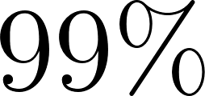](https://www.codecogs.com/eqnedit.php?latex=99%5C%25#0) of terminal velocity:

[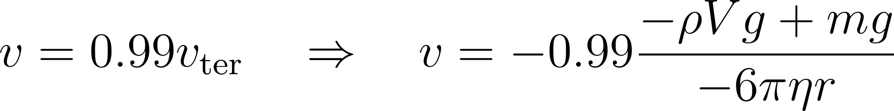](https://www.codecogs.com/eqnedit.php?latex=v%20%3D%200.99%20v_%7B%5Ctext%7Bter%7D%7D%20%5Cquad%20%5CRightarrow%20%5Cquad%20v%20%3D%20-0.99%20%5Cfrac%7B-%5Crho%20Vg%2Bmg%7D%7B-6%5Cpi%20%5Ceta%20r%7D#0)

Substitute:

[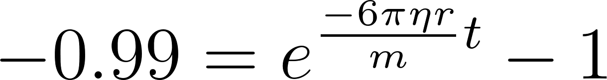](https://www.codecogs.com/eqnedit.php?latex=-0.99%20%3D%20e%5E%7B%5Cfrac%7B-6%5Cpi%20%5Ceta%20r%7D%7Bm%7Dt%7D%20-%201#0)

Taking the natural logarithm:

[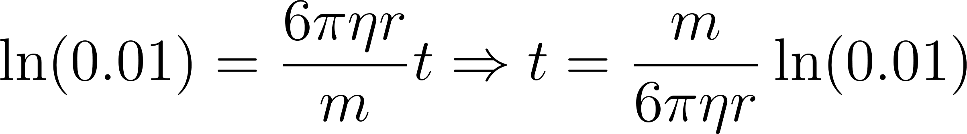](https://www.codecogs.com/eqnedit.php?latex=%5Cln(0.01)%20%3D%20%5Cfrac%7B6%5Cpi%20%5Ceta%20r%7D%7Bm%7Dt%20%5CRightarrow%20t%20%3D%20%5Cfrac%7Bm%7D%7B6%5Cpi%20%5Ceta%20r%7D%20%5Cln(0.01)#0)

[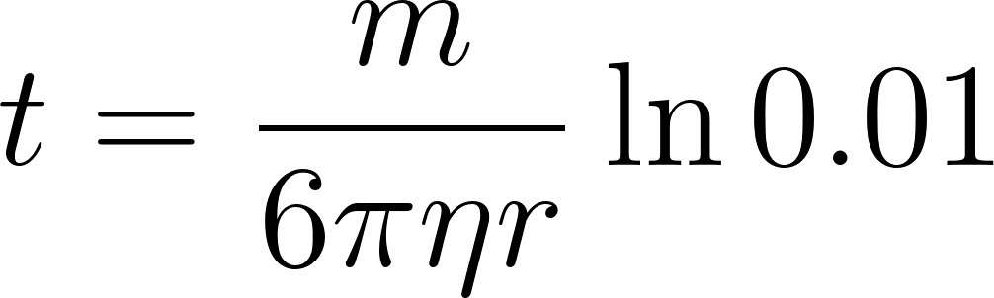](https://www.codecogs.com/eqnedit.php?latex=t%3D%5Cfrac%7Bm%7D%7B6%20%5Cpi%20%5Ceta%20r%7D%5Cln%200.01#0)

Since the six nominal sphere sizes will each be measured three times using different spheres, I need to take the average of the radii to obtain a single representative value for each nominal size. This is done to minimize random errors and provide more accurate values.

Average of the radii:

[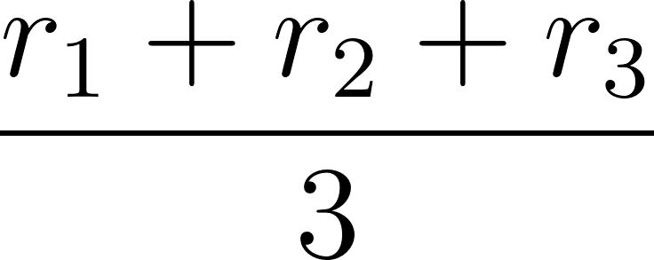](https://www.codecogs.com/eqnedit.php?latex=%5Cfrac%7Br_1%2Br_2%2Br_3%7D%7B3%7D#0)

[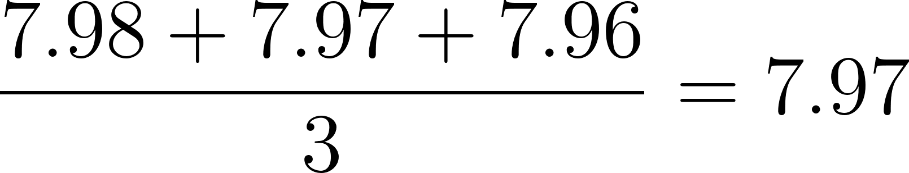](https://www.codecogs.com/eqnedit.php?latex=%5Cfrac%7B7.98%2B7.97%2B7.96%7D%7B3%7D%3D7.97#0)

Uncertainty of the mean of the radii

[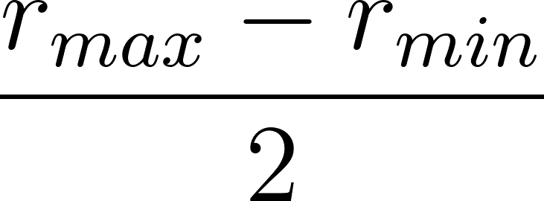](https://www.codecogs.com/eqnedit.php?latex=%5Cfrac%7Br_%7Bmax%7D-r_%7Bmin%7D%7D%7B2%7D#0)

[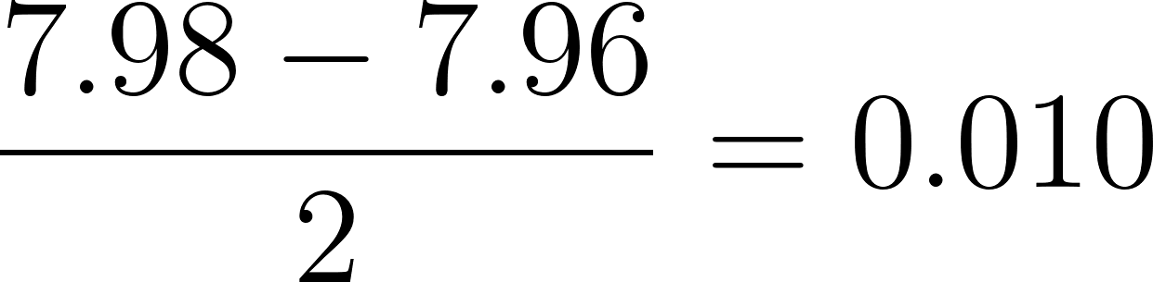](https://www.codecogs.com/eqnedit.php?latex=%5Cfrac%7B7.98-7.96%7D%7B2%7D%3D0.010#0)

This is uncertainty due to the manufacturing precision. My measuring tool (caliper) had an uncertainty of 0.02 mm, which is larger. Therefore, its uncertainty is the dominant one. This applies to all spheres, so all uncertainties of radius are taken at 0.02 mm.

Thus, all sample calculations were performed specifically for the sphere with a radius of 7.97 ± 0.02 mm.

To find an order of magnitude of [](https://www.codecogs.com/eqnedit.php?latex=t#0), I will use the mass of a sphere from the set all the spheres of the experiment are coming from, which is 2.064 g, its radius of 8 mm, and a typical viscosity of glycerin found online of 1.4 Pa s.

Where:

* [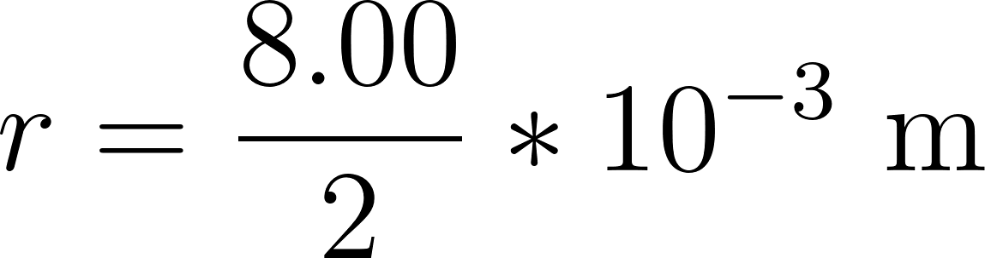](https://www.codecogs.com/eqnedit.php?latex=r%3D%5Cfrac%7B8.00%7D%7B2%7D*10%5E%7B-3%7D%20%5Ctext%7B%20m%7D#0)
* [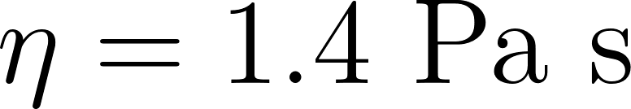](https://www.codecogs.com/eqnedit.php?latex=%5Ceta%20%3D%201.4%5Ctext%7B%20Pa%20s%7D#0)
* [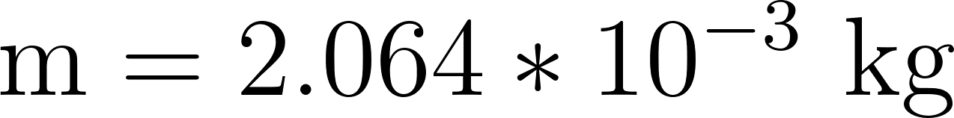](https://www.codecogs.com/eqnedit.php?latex=%5Ctext%7Bm%7D%3D2.064*10%5E%7B-3%7D%5Ctext%7B%20kg%7D#0)

[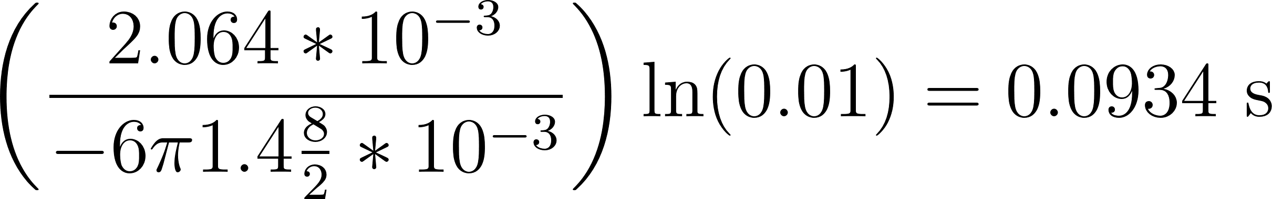](https://www.codecogs.com/eqnedit.php?latex=%5Cleft(%20%5Cfrac%7B2.064*10%5E%7B-3%7D%7D%7B-6%20%20%5Cpi%201.4%20%5Cfrac%7B8%7D%7B2%7D*10%5E%7B-3%7D%7D%20%5Cright)%20%5Cln(0.01)%3D0.0934%5Ctext%7B%20s%7D#0)

This result shows that the terminal velocities of the spheres are achieved very fast, meaning that we can take a high point in the graduated cylinder to reduce uncertainties. That also means we can calculate the speed by dividing the distance by time.

It is needless to calculate the time for other spheres because the order of magnitude of the time is very small. It is also needless to calculate uncertainties here, as we are only calculating an order of magnitude.

Therefore, the steps followed are:

1. Pour 1 L of glycerin into a measuring jug and weigh without counting the weight of the jug.
2. Measure the size of a sphere and its weight
3. Put a mark where time starts to be measured.
4. Put a mark where time stops to be measured at 0.192 ± 0.00002 m from the first mark
5. Pour the glycerin into the tube in a way to avoid bubbles
6. Measure the temperature of the glycerin
7. Setup the camera at a good height and angle
8. Start the camera
9. Measure the diameter of the spheres using an electronic caliper
10. Place a sphere at the top of the tube completely submerged in glycerin
11. Drop the sphere without impulsion
12. Stop the camera
13. Upload the video to Tracker
14. Measure the time it took the sphere to go from the top mark to the bottom mark
15. Divide the distance with the measured time to get the terminal velocity
16. Repeat the steps 9-11 for all the remaining 17 spheres

If the container is too narrow, the walls introduce additional drag force on the sphere due to increased wall-induced fluid resistance, altering the terminal velocity of the sphere (Donatus Hun et al., 2024). Furthermore, if the container is too short, insufficient settling distance can result in turbulence and unsteady flow conditions, increasing drag force (OpenStax College, n.d.). So, I chose a graduated cylinder that is not too narrow or short.

### 2.3 Diagram

Figure 1: Experimental setup

Figure 2: Experimental Setup

### 2.4 Risk Assessment

| **Hazard** | **Potential Risk** | **Precautionary Measures** |
| --- | --- | --- |
| Safety Risk | Glass Container Breaking | Handle glassware with care and use a secure, flat surface. |
|  | Spilled Glycerin | Immediately clean any spills, conduct the experiment on a flat and stable surface, and wear non-slip shoes, as glycerin is a slippery liquid. |
|  | Allergic reaction to glycerin | Use gloves to minimize direct contact and wash hands thoroughly after handling glycerin. |
| Environmental Risk | Waste Glycerin | Hand glycerin carefully and conduct the experiment on a flat, stable surface. |
| Ethical Risk | Ethical dilemmas | There was no use of living organisms or ethical dilemmas. |

## 3 Analysis

First, the theoretical terminal velocities of spheres with different radii are determined using the formula outlined in the Background Theory section.

1. Using the formula we got earlier in the background theory section:

[](https://www.codecogs.com/eqnedit.php?latex=%20v_s%20%3D%20%5Cfrac%7B2%20r%5E2%20g%20(%5Crho_s%20-%20%5Crho_f)%7D%7B9%20%5Ceta_f%7D%20%20#0)

Where:

* [](https://www.codecogs.com/eqnedit.php?latex=r%3D7.97%20%5Cpm%200.02%5Ctext%7B%20mm%7D#0)
* [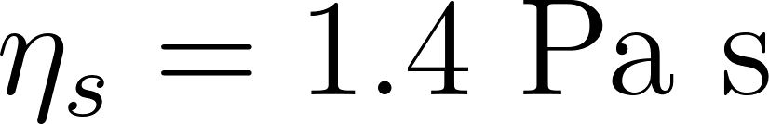](https://www.codecogs.com/eqnedit.php?latex=%5Ceta%20_s%20%3D%201.4%5Ctext%7B%20Pa%20s%7D#0)
* [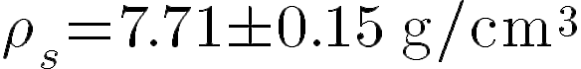](http://www.texrendr.com/?eqn=%5Crho%20_s%3D7.71%5Cpm%200.15%5Ctext%7B%20g%2Fcm%5E3%7D#0) value found in the “Important values” section, page 7.
* [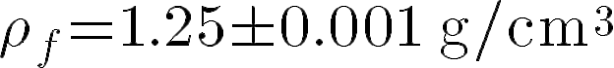](http://www.texrendr.com/?eqn=%5Crho%20_f%3D1.25%5Cpm%200.001%5Ctext%7B%20g%2Fcm%5E3%7D#0) value found in the “Important values” section, page 7.

[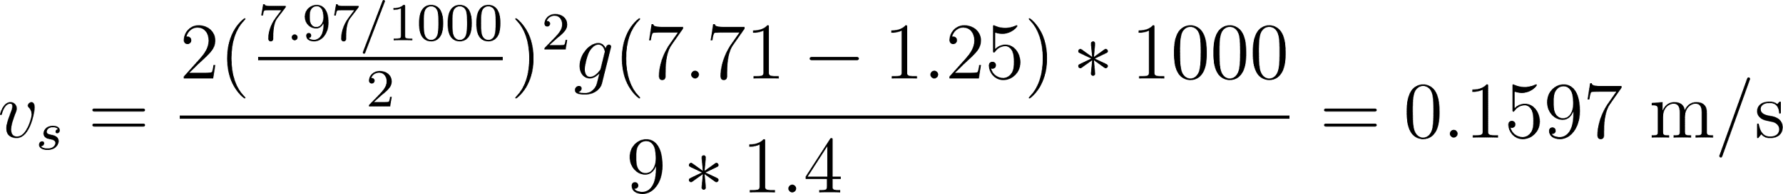](https://www.codecogs.com/eqnedit.php?latex=%20v_s%20%3D%20%5Cfrac%7B2%20(%5Cfrac%7B7.97%2F1000%7D%7B2%7D)%5E2%20g%20(7.71%20-%201.25)*1000%7D%7B9*1.4%7D%3D0.1597%5Ctext%7B%20m%2Fs%7D#0)

1. Calculating the uncertainty for the theoretical terminal velocities:

For a function of multiple independent variables:

[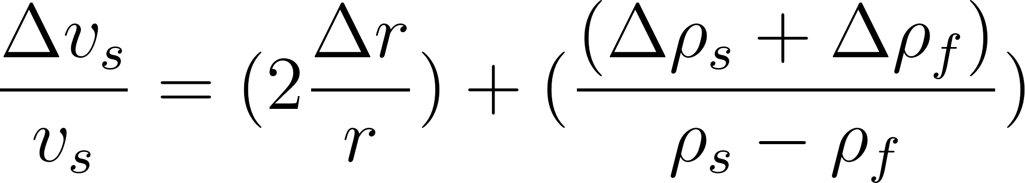](https://www.codecogs.com/eqnedit.php?latex=%5Cfrac%7B%5CDelta%20v_s%7D%7Bv_s%7D%3D(2%5Cfrac%7B%5CDelta%20r%7D%20%7Br%7D)%2B(%5Cfrac%7B%20(%5CDelta%5Crho%20_s%2B%5CDelta%5Crho%20_f)%7D%7B%5Crho%20_s-%5Crho%20_f%7D)#0)

We already found earlier that 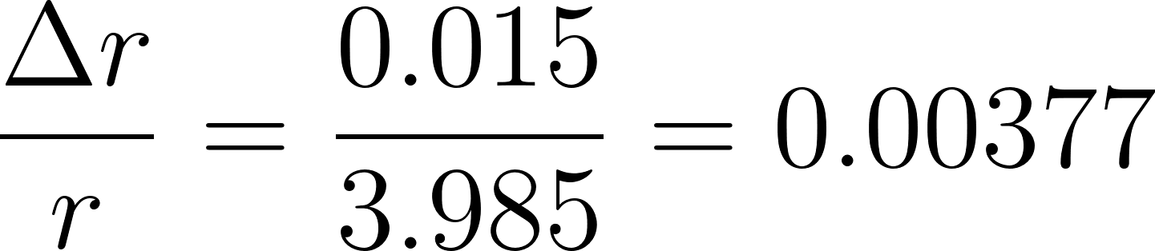. However, we need to find the uncertainty in ([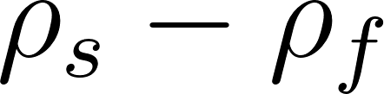](https://www.codecogs.com/eqnedit.php?latex=%5Crho%20_s-%5Crho%20_f#0)):

Since:

[](https://www.codecogs.com/eqnedit.php?latex=%5CDelta%20%5Crho%20_s%3D0.15%5Ctext%7B%20and%20%7D%5CDelta%20%5Crho%20_f%3D0.001#0)

The uncertainty is:

[](https://www.codecogs.com/eqnedit.php?latex=%5CDelta%5Crho%20_s-%5Crho%20_f%3D0.15%2B0.001%3D0.151#0)

Thus:

[](https://www.codecogs.com/eqnedit.php?latex=(2*0.00377)%2B0.151%3D0.15854#0)

Finally:

[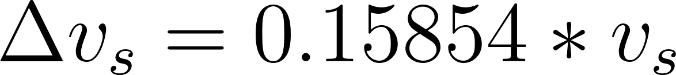](https://www.codecogs.com/eqnedit.php?latex=%5CDelta%20v_s%3D0.15854*v_s#0)

Then, the Reynolds number must be calculated to ensure the flow around the spheres is laminar.

1. Calculating the Reynolds number of the spheres using the formula from the background theory:

[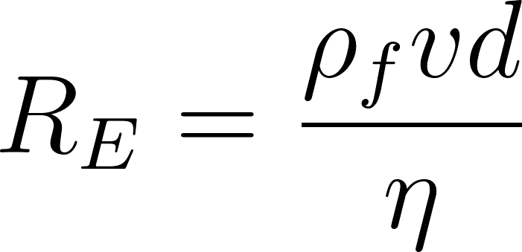](https://www.codecogs.com/eqnedit.php?latex=R_E%3D%5Cfrac%7B%5Crho_f%20vd%7D%7B%5Ceta%7D#0)

Where:

* [](https://www.codecogs.com/eqnedit.php?latex=v%3D0.1632%20%5Cpm%200.00398%20m%2Fs#0)
* [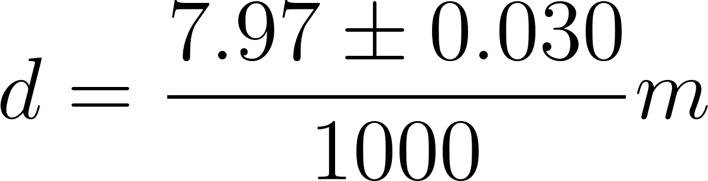](https://www.codecogs.com/eqnedit.php?latex=d%3D%5Cfrac%7B7.97%20%5Cpm%200.030%7D%7B1000%7D%20m#0)
* [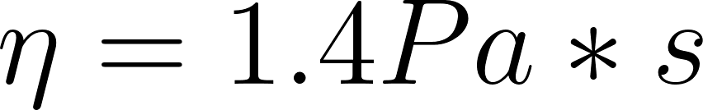](https://www.codecogs.com/eqnedit.php?latex=%5Ceta%20%3D%201.4%5Cspace%20Pa*s#0)

[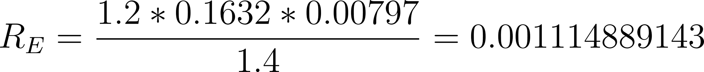](https://www.codecogs.com/eqnedit.php?latex=R_E%3D%5Cfrac%7B1.2*0.1632*0.00797%7D%7B1.4%7D%3D0.001114889143#0)

It is needless to calculate uncertainties here, as we are only calculating an order of magnitude. The order of magnitude is [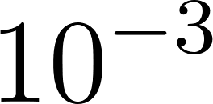](https://www.codecogs.com/eqnedit.php?latex=10%5E%7B-3%7D#0).

| **Diameter of the body** | **Reynolds number** | **Theoretical terminal velocity** | **Uncertainty of the theoretical terminal velocity** |
| --- | --- | --- | --- |
| 7.97 ±0.01 | 0.0011 | 0.16 | 0.03 |
| 6.98 ±0.04 | 0.00075 | 0.13 | 0.02 |
| 6.00 ± 0.005 | 0.00048 | 0.09 | 0.01 |
| 5.55 ± 0.01 | 0.00038 | 0.08 | 0.01 |
| 4.48 ± 0.01 | 0.00020 | 0.052 | 0.008 |
| 3.50 ± 0.000 | 0.000095 | 0.031 | 0.005 |

Table 2: Reynolds number and theoretical terminal velocity

The Reynolds number of each sphere is way below 1, meaning that we can ensure that the assumptions of Stokes’ Law are valid.

### 3.1 Raw Data

The raw data consists of the measured time it took for each sphere to travel in glycerin at a fixed distance of 0.192 ± 0.00002 m, as discussed in the procedure section. Each measurement was repeated for three spheres of the same size to ensure reliability. The diameters and times for each trial are shown below. I will also select the larger calculated uncertainty between the range/2 and 0.017 s due to the camera filming at 60 fps, preventing underestimation of measurement errors.

| **Diameter of the body** | | | | **Time** | | | | |
| --- | --- | --- | --- | --- | --- | --- | --- | --- |
| Try 1 | Try 2 | Try 3 | Average | Try 1 | Try 2 | Try 3 | Average | max(range/2;0.017) |
| 7.98 | 7.97 | 7.96 | 7.97 | 1.217 | 1.217 | 1.200 | 1.211 | 0.17 |
| 7.02 | 6.97 | 6.95 | 6.98 | 1.417 | 1.403 | 1.433 | 1.418 | 0.17 |
| 6.00 | 6.00 | 5.99 | 6.00 | 1.783 | 1.783 | 1.783 | 1.783 | 0.17 |
| 5.56 | 5.55 | 5.54 | 5.55 | 2.033 | 2.017 | 2.000 | 2.017 | 0.17 |
| 4.49 | 4.48 | 4.47 | 4.48 | 2.817 | 2.800 | 2.817 | 2.811 | 0.17 |
| 3.50 | 3.50 | 3.50 | 3.50 | 4.383 | 4.383 | 4.383 | 4.383 | 0.17 |

Table 3: Raw Data

### 3.2 Processed Data

Since the spheres reach their terminal velocity quickly, we can apply the formula for the average velocity to calculate the terminal velocity for each trial.

To calculate the terminal velocity:

[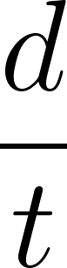](https://www.codecogs.com/eqnedit.php?latex=%5Cfrac%7Bd%7D%7Bt%7D#0)

Where I take the average of the nominal sizes:

* [](https://www.codecogs.com/eqnedit.php?latex=d%3D0.192%5Cpm%200.00002%5Ctext%7B%20m%7D#0)
* [](https://www.codecogs.com/eqnedit.php?latex=t%3D1.211%5Cpm%200.017%5Ctext%7B%20s%7D#0)

[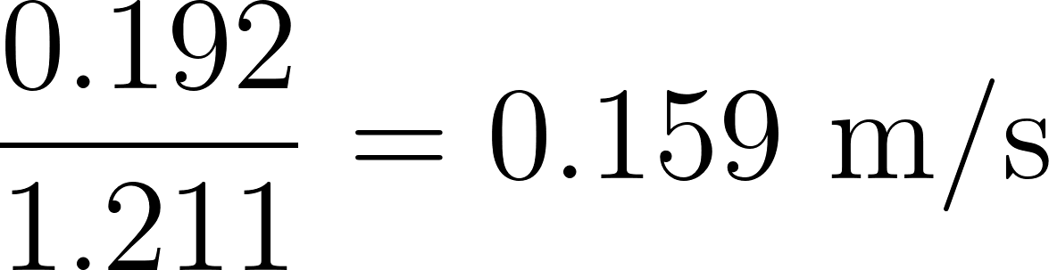](https://www.codecogs.com/eqnedit.php?latex=%5Cfrac%7B0.192%7D%7B1.211%7D%3D0.159%5Ctext%7B%20m%2Fs%7D#0)

To calculate the uncertainty propagation:

[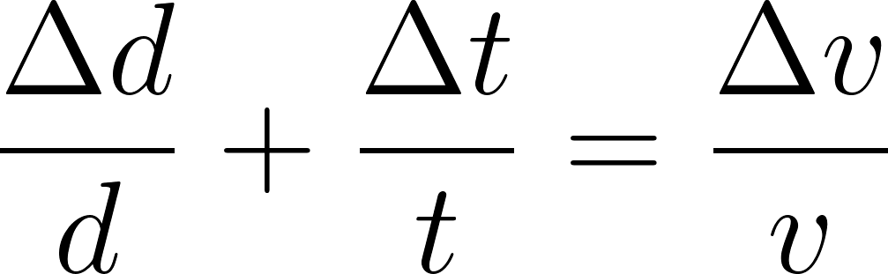](https://www.codecogs.com/eqnedit.php?latex=%5Cfrac%7B%5CDelta%20d%7D%7Bd%7D%2B%5Cfrac%7B%5CDelta%20t%7D%7Bt%7D%3D%5Cfrac%7B%5CDelta%20v%7D%7Bv%7D#0)

[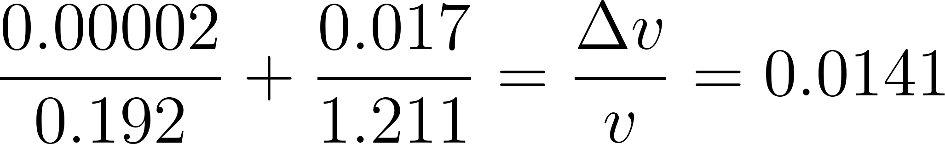](https://www.codecogs.com/eqnedit.php?latex=%5Cfrac%7B0.00002%7D%7B0.192%7D%2B%5Cfrac%7B0.017%7D%7B1.211%7D%3D%5Cfrac%7B%5CDelta%20v%7D%7Bv%7D%3D0.0141#0)

[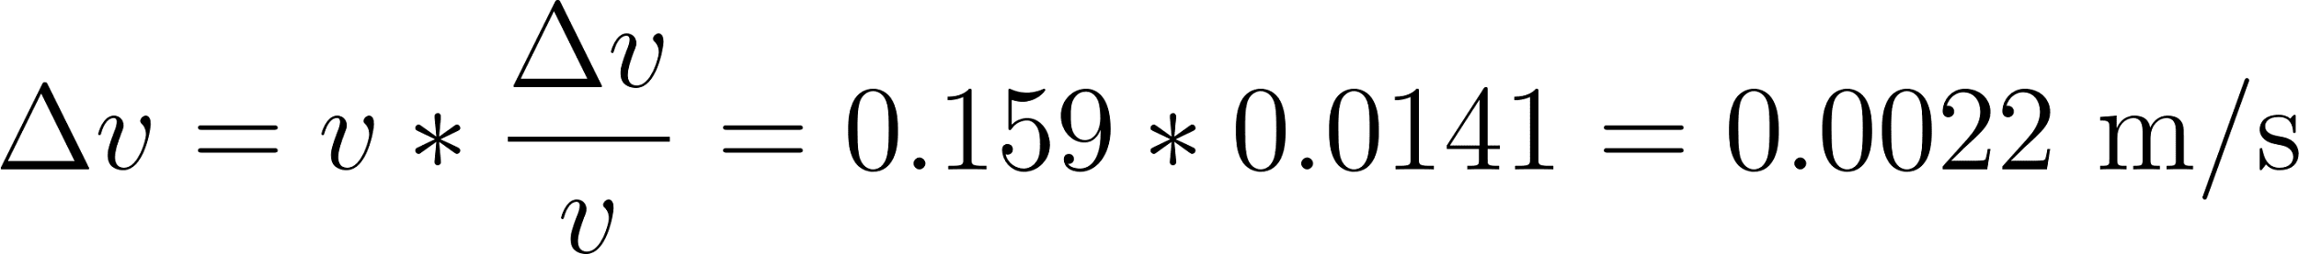](https://www.codecogs.com/eqnedit.php?latex=%5CDelta%20v%3Dv*%5Cfrac%7B%5CDelta%20v%7D%7Bv%7D%3D0.159*0.0141%3D0.0022%5Ctext%7B%20m%2Fs%7D#0)

| **Diameter of the body**   ± 0.02 mm | **Experimental Terminal velocity** | **Uncertainty of the terminal velocity** |
| --- | --- | --- |
| 7.97 | 0.159 | 0.002 |
| 6.98 | 0.135 | 0.002 |
| 6.00 | 0.108 | 0.002 |
| 5.55 | 0.095 | 0.0009 |
| 4.48 | 0.068 | 0.001 |
| 3.50 | 0.044 | 0.0006 |

Table 4: Experimental Terminal velocity

### 3.3 Graphical Analysis

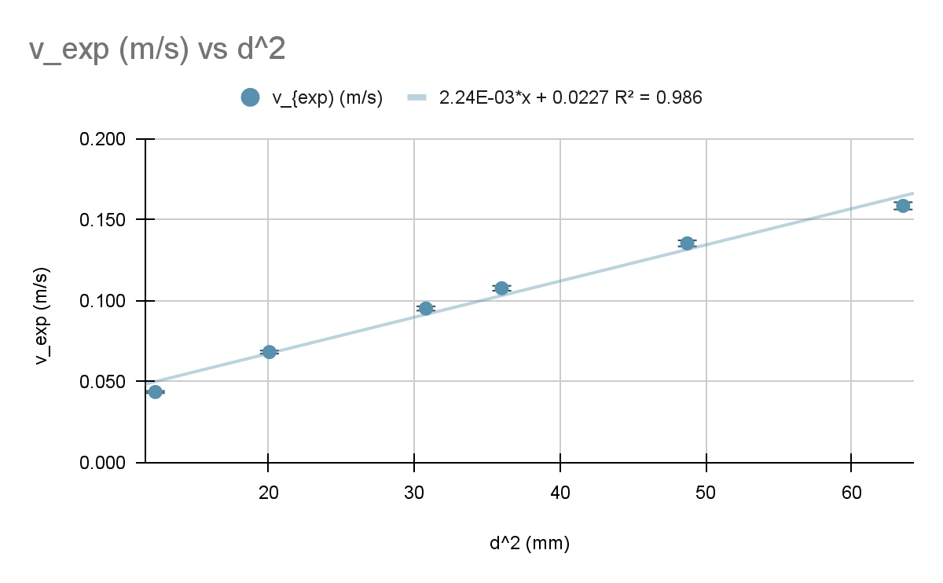  
Figure 3: Experimental terminal velocities vs diameter squared (mm²)

The graph in Figure 2 shows the experimental terminal velocity ([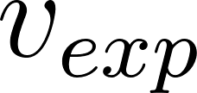](https://www.codecogs.com/eqnedit.php?latex=v_%7Bexp%7D#0)) plotted against the square of the spheres' diameter ([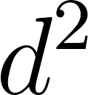](https://www.codecogs.com/eqnedit.php?latex=d%5E2#0)). The graph displays a linear relationship between [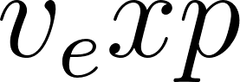](https://www.codecogs.com/eqnedit.php?latex=v_exp#0) and [](https://www.codecogs.com/eqnedit.php?latex=d%5E2#0), which supports the theoretical model in predicting a direct proportionality between terminal velocity and [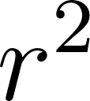](https://www.codecogs.com/eqnedit.php?latex=r%5E2#0). The slope reflects the combined effects of fluid viscosity, sphere density, and gravitational acceleration. A steeper slope, larger [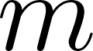](https://www.codecogs.com/eqnedit.php?latex=m#0), would indicate a lower viscosity fluid or greater density difference between the spheres and fluid. The equation of the line fit is [](https://www.codecogs.com/eqnedit.php?latex=v_%7Bexp%7D%3D2.24*10%5E%7B-3%7D*d%5E2%2B0.0227#0) with an [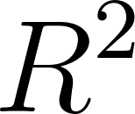](https://www.codecogs.com/eqnedit.php?latex=R%5E2#0) value of [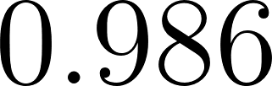](https://www.codecogs.com/eqnedit.php?latex=0.986#0), confirming the validity of the linear correlation between the terminal velocity and the radius². This demonstrates that the experimental data matches the theoretical model derived from Stokes’ Law to a significant extent. As a result, the viscosity calculation that will be conducted in the next page based on the experimental data can be considered quite reliable.

The theoretical formula for terminal velocity is:

[](https://www.codecogs.com/eqnedit.php?latex=%20v_s%20%3D%20%5Cfrac%7B2%20r%5E2%20g%20(%5Crho_s%20-%20%5Crho_f)%7D%7B9%20%5Ceta_f%7D%20%20#0)

Since [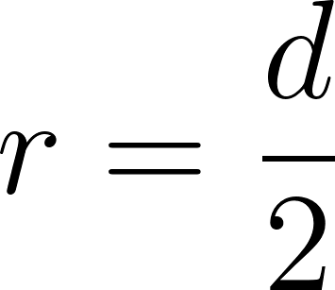](https://www.codecogs.com/eqnedit.php?latex=r%3D%5Cfrac%7Bd%7D%7B2%7D#0), it can be substituted into [](https://www.codecogs.com/eqnedit.php?latex=r%5E2#0)

[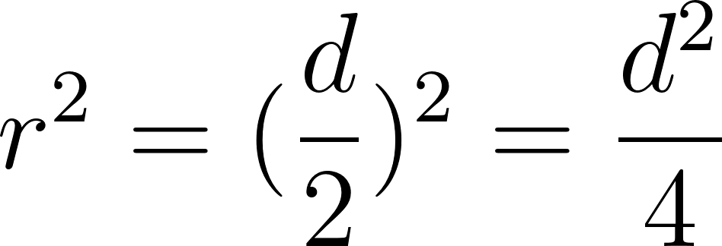](https://www.codecogs.com/eqnedit.php?latex=r%5E2%3D(%5Cfrac%7Bd%7D%7B2%7D)%5E2%3D%5Cfrac%7Bd%5E2%7D%7B4%7D#0)

Now, [](https://www.codecogs.com/eqnedit.php?latex=r%5E2#0) can be substituted into the formula:

[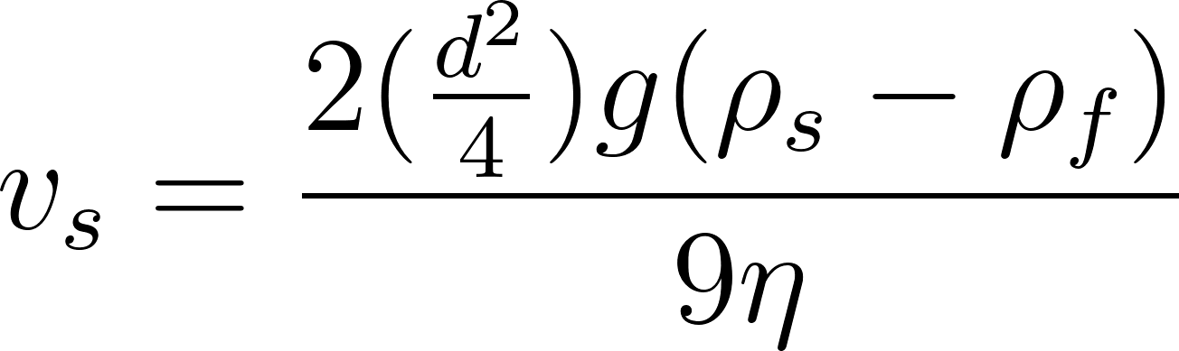](https://www.codecogs.com/eqnedit.php?latex=v_s%3D%5Cfrac%7B2(%5Cfrac%7Bd%5E2%7D%7B4%7D)g(%5Crho%20_s%20-%20%5Crho%20_f)%7D%7B9%5Ceta%7D#0)

Simplify:

[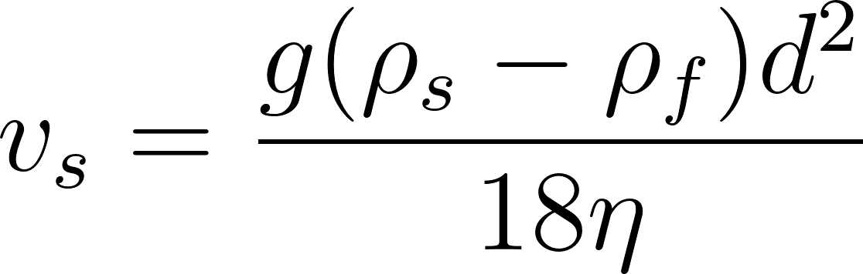](https://www.codecogs.com/eqnedit.php?latex=v_s%3D%5Cfrac%7Bg(%5Crho%20_s%20-%20%5Crho%20_f)d%5E2%7D%7B18%5Ceta%7D#0)

The slope of the graph [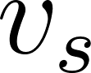](https://www.codecogs.com/eqnedit.php?latex=v_s#0) vs. [](https://www.codecogs.com/eqnedit.php?latex=d%5E2#0) is the coefficient of [](https://www.codecogs.com/eqnedit.php?latex=d%5E2#0) in the equation:

[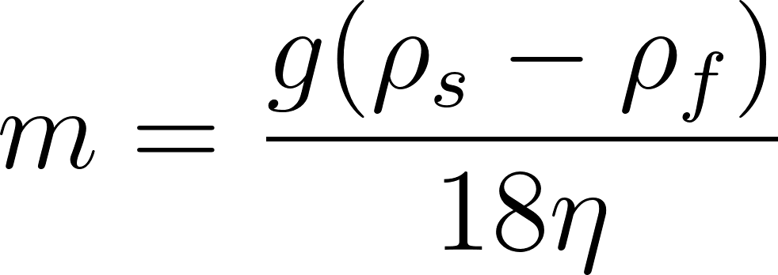](https://www.codecogs.com/eqnedit.php?latex=m%3D%5Cfrac%7Bg(%5Crho%20_s%20-%20%5Crho%20_f)%7D%7B18%5Ceta%7D#0)

Rearranging to solve for the slope:

[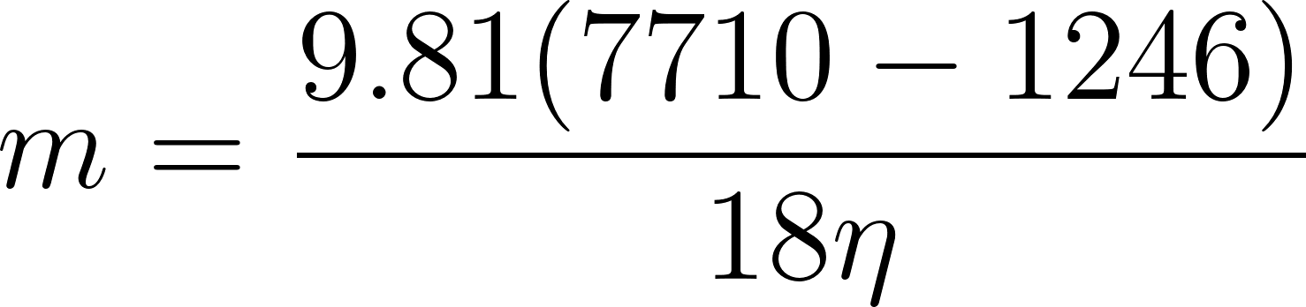](https://www.codecogs.com/eqnedit.php?latex=m%3D%5Cfrac%7B9.81(7710-1246)%7D%7B18%5Ceta%7D#0)

Simplify:

[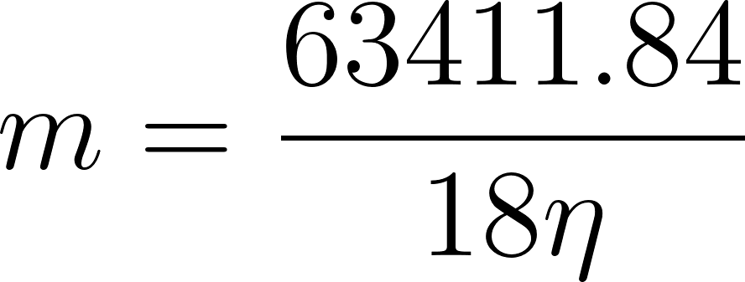](https://www.codecogs.com/eqnedit.php?latex=m%3D%5Cfrac%7B63411.84%7D%7B18%5Ceta%7D#0)

From the graph, the slope is:

[](http://www.texrendr.com/?eqn=m%3D2.24*10%5E%7B-3%7D%5Ctext%7B%20m%2Fs%2Fmm%5E2%7D%5CRightarrow%202.24*10%5E%7B-3%7D*10%5E6%3D2240%5Ctext%7B%20m%2Fs%2Fm%5E2%7D#0)

Set the two slopes equal:

[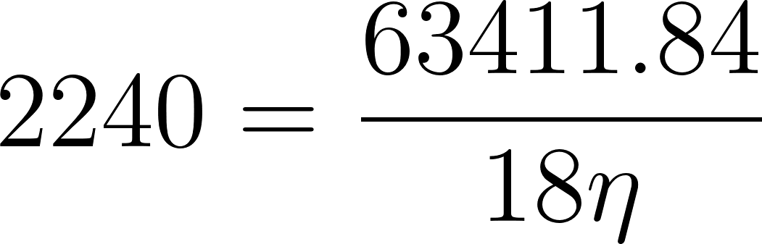](https://www.codecogs.com/eqnedit.php?latex=2240%3D%5Cfrac%7B63411.84%7D%7B18%5Ceta%7D#0)

[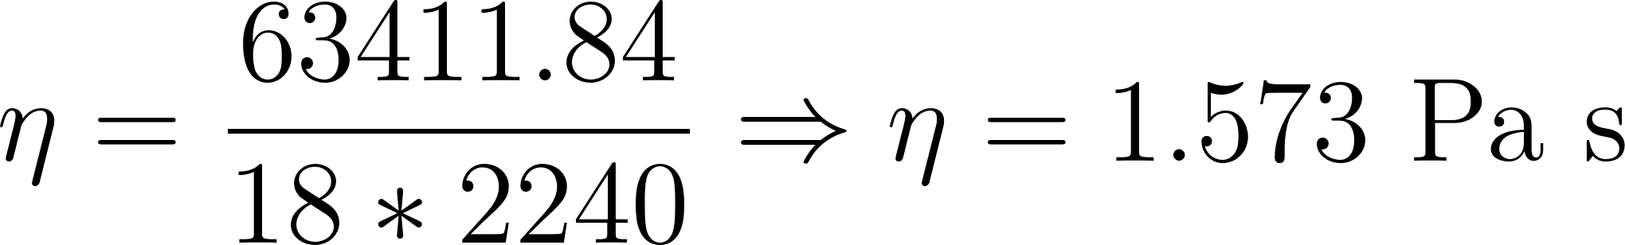](https://www.codecogs.com/eqnedit.php?latex=%5Ceta%20%3D%5Cfrac%7B63411.84%7D%7B18*2240%7D%5CRightarrow%20%5Ceta%20%3D1.573%20%5Ctext%7B%20Pa%20s%7D#0)

Find the %error between the experimental viscosity and the one found online:

[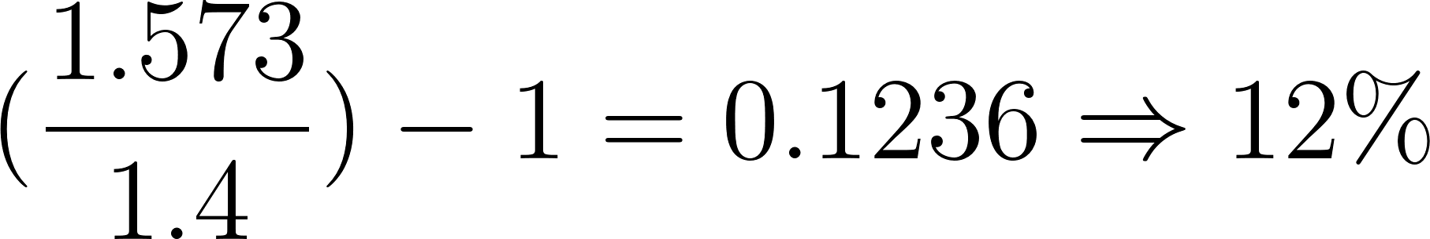](https://www.codecogs.com/eqnedit.php?latex=(%5Cfrac%7B1.573%7D%7B1.4%7D)-1%3D0.1236%5CRightarrow%2012%25#0)

This slight difference of [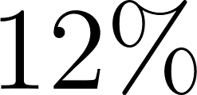](https://www.codecogs.com/eqnedit.php?latex=12%25#0) shows that the experiment is successful. It is probably explained by the exact type of glycerin that we used, which is not the same as that of that online reference. Trapped air bubbles in the glycerin during the pouring process could be another reason.

### 3.4 Conclusion

After carrying out data collection, analysis, and plotting a graph of the result, it can be seen that the results of this investigation confirmed a positive, proportional relationship between the diameter of a sphere and its terminal velocity in 99.5% glycerin Both experimental and theoretical data supported the hypothesis that terminal velocity increases with the square of the sphere’s radius, consistent with predictions from Stokes' Law. The high R² value of 0.986 from the linear regression analysis demonstrates a strong alignment between theory and experimental outcomes. Specifically, Stokes' Law, which describes the proportional relationship between the terminal velocity of a sphere and the square of its radius in a viscous fluid under laminar flow conditions

The variance between the experimental and theoretical values was more pronounced for smaller spheres, where a higher %Error occurred. These deviations can be due to certain limitations, such as the increased relative uncertainty in diameter measurements for smaller spheres, the presence of air bubbles in the glycerin affecting its viscosity, slight misalignments or wobbling during the release of spheres, and potential surface effects that become more significant at smaller scales. Despite these factors, the experiment successfully demonstrated the physical theory of the investigation.

## 

## 4 Evaluation

### 4.2 Limitation

| Variation in Sphere Properties | Using different spheres for the same nominal size may have introduced inconsistencies, as slight differences between the spheres of the same nominal size in diameter, shape, or surface smoothness could affect the drag force and, thus, the terminal velocity. But this allowed a considerable gain of time of time. |
| --- | --- |
| Small Sphere Sizes | While Stokes' Law applies under laminar flow, very small spheres may experience slight deviations in behavior due to surface effects or turbulence near the surface of the glycerin, even if the Reynolds number is low. Furthermore, for smaller spheres, factors such as air bubbles, misalignment during release, or slight inconsistencies in the fluid's properties (temperature or density) could contribute more noticeably to the error. |
| Air Bubbles in Glycerin | The high viscosity of glycerin made it difficult to eliminate all trapped air bubbles, potentially altering the fluid's overall viscosity and introducing variability in the results, despite all attempts to pour the glycerin slowly and on the walls of the container. |
| Surface Effects and Turbulence | Although the Reynolds number of all the spheres is way below 1, assuring laminar flow, slight surface imperfections or turbulence near the sphere's surface could have caused deviations, particularly for smaller spheres. |
| Release Misalignments | As I released the spheres during the experiment, minor misalignments or wobbling may have occurred, increasing the drag force by temporarily altering the cross-sectional area exposed to the fluid. |

### 4.3 Extensions and Modifications

The first modification I would make is to include larger spheres in the experiment to see whether the observed trend continues beyond the tested range, as it seems like the trend changed for the larger sphere. Second, I would use a vacuum chamber or a more controlled method to remove air bubbles from the glycerin before the experiment to ensure the fluid’s viscosity remains constant and unaffected by trapped bubbles. Third, I would use a mechanical holder to hold and release the ball to avoid minor misalignments or wobbling. Finally, I would conduct multiple trials using the exact same sphere for each size by using a magnet to get the sphere back to eliminate variations caused by small differences between nominally identical spheres.

## References

Aaron. (2022). *What factors affect terminal velocity?* Tutorchase.com. https://www.tutorchase.com/answers/ib/physics/what-factors-affect-terminal-velocity

Amardeep Steel Centre. (2024). *Density of Steel - Mild and Carbon Steel Density lb/in3 or kg/m3*. Amardeepsteel.com. https://www.amardeepsteel.com/blog/density-of-steel.html

Benson, T. (2024). *Terminal Velocity*. Www.grc.nasa.gov; NASA. https://www.grc.nasa.gov/www/k-12/VirtualAero/BottleRocket/airplane/termv.html

COMSOL Documentation. (2021). *Particle Motion in a Fluid*. Comsol.com. https://doc.comsol.com/5.6/docserver/#

Deziel, C. (2020, December 22). *How To Calculate Density Of Sphere*. Sciencing. https://www.sciencing.com/calculate-density-sphere-5529785/

Donatus Hun, H., Manzilah, R., Fahra, M., Putri, B., Aufia, Y., Jubaedah, J., & Program, T. (2024). Understanding the Terminal Velocity of Particle Motion in Fluids at the Senior High School Level with Numerical Experiments. *International Journal of STEM Education for Sustainibility*, *4*(2), 213–228. https://doi.org/10.52889/ijses.v4i2.389

Fluigent. (2023, November 23). *Addressing Air Bubble Issues in Microfluidic Systems - Fluigent*. Fluigent - Smart Microfluidics. https://www.fluigent.com/resources-support/expertise/avoid-air-bubbles/

Grugel, M. (1998). *Modeling the viscous torque acting on a rotating object*. https://physics.wooster.edu/wp-content/uploads/2021/08/Junior-IS-Thesis-Web_1998_Grugel.pdf

Javatpoint. (2024). *Terminal Velocity - Javatpoint*. Www.javatpoint.com. https://www.javatpoint.com/terminal-velocity

Kagan, D. (2018, November 12). *The Physics of a Wobbling Fly Ball*. The Hardball Times. https://tht.fangraphs.com/the-physics-of-a-wobbling-fly-ball/

Khan Academy. (2023). *Khan Academy*. Khanacademy.org. https://www.khanacademy.org/science/ap-college-physics-1/xf557a762645cccc5:fluids/xf557a762645cccc5:buoyant-force/a/buoyant-force-and-archimedes-principle-article

Lumen Learning. (2022). *Drag Forces | Physics*. Courses.lumenlearning.com. https://courses.lumenlearning.com/suny-physics/chapter/5-2-drag-forces/

OpenStax College. (n.d.). *Motion of an Object in a Viscous Fluid | Physics*. Courses.lumenlearning.com. Retrieved December 28, 2024, from https://courses.lumenlearning.com/suny-physics/chapter/12-6-motion-of-an-object-in-a-viscous-fluid/

Rehm, B., & Schubert, J. (2008). *Reynolds’ Number - an overview | ScienceDirect Topics*. Sciencedirect.com. https://www.sciencedirect.com/topics/engineering/reynolds-number

Springer Verlag. (2013). *Table 1 Glycerin properties at different temperatures*. ResearchGate; ResearchGate. https://www.researchgate.net/figure/Glycerin-properties-at-different-temperatures_tbl1_257403743

University of Tennessee. (n.d.). *Weight*. Labman.phys.utk.edu. Retrieved December 24, 2024, from http://labman.phys.utk.edu/phys135core/modules/m4/weight.html

votatera. (2024, May 27). *Terminal Velocity | Dynamics, Motion & Air Resistance*. Modern Physics Insights: Discover, Understand, Innovate. https://modern-physics.org/terminal-velocity/